

KARNAVATI UNIVERSITY
UnitedWorld Institute of Technology

PROJECT REPORT
On:

VIDURA
AI-Powered Intelligent Law Enforcement
Documentation & Investigation Assistant

Submitted By:
TEAM ~Unknown Creators
Parth Sidhapura
Rahil Prajapati
Dhairya Poojara
Yug Patel

ACKNOWLEDGEMENT
The successful completion of VIDURA – AI-Powered Intelligent Law Enforcement Documentation & Investigation Assistant marks the culmination of extensive research, innovation, collaboration, and continuous learning. This project represents our collective effort to explore how Artificial Intelligence can be utilized to modernize law enforcement documentation, improve investigative efficiency, and assist police officers in making informed decisions through intelligent automation.
We express our deepest gratitude to Karnavati University and the UnitedWorld Institute of Technology for providing an environment that encourages innovation, technical excellence, and practical learning. The knowledge, resources, and academic support provided by the university have played a significant role in shaping our understanding of modern technologies and their application in solving real-world challenges.
We sincerely thank our respected faculty members and mentors for their valuable guidance, continuous encouragement, and constructive feedback throughout every phase of this project. Their suggestions helped us improve the overall architecture, strengthen our problem-solving approach, and maintain a structured development process. Their mentorship inspired us to think beyond conventional solutions and focus on building a system capable of addressing practical challenges faced by law enforcement agencies.
Our heartfelt appreciation goes to every member of Team Unknown Creators for their dedication, teamwork, and commitment during the planning, research, design, development, and testing phases of the project. The collaborative environment within our team enabled us to effectively overcome technical challenges, exchange innovative ideas, and continuously improve the quality of our solution.
We are also thankful to the hackathon organizers for creating a platform that motivates students to transform innovative ideas into practical solutions with real-world impact. Participating in this event has provided us with invaluable exposure to collaborative development, rapid prototyping, problem-solving under time constraints, and the importance of designing scalable technology solutions.
Throughout the development of VIDURA, we explored advanced technologies including Artificial Intelligence, Natural Language Processing (NLP), Retrieval-Augmented Generation (RAG), Speech-toText Processing, Secure Cloud Computing, Modern Web Technologies, and Cybersecurity principles. Working on this project has significantly enhanced our technical knowledge while strengthening our skills in software engineering, teamwork, communication, and system design.
Finally, we express our gratitude to everyone who directly or indirectly contributed to the successful completion of this project. We sincerely hope that VIDURA serves as a meaningful step toward the digital transformation of law enforcement documentation and inspires future innovations that improve public safety, operational efficiency, and transparency through the responsible use of Artificial Intelligence.

Team ~ Unknown Creators
"Innovation is meaningful only when it solves real-world problems. VIDURA is our step towards empowering law enforcement through Artificial Intelligence."

TABLE OF CONTENTS
Contents
KARNAVATI UNIVERSITY 1
ACKNOWLEDGEMENT 2
ABSTRACT 4
INTRODUCTION 5
PROBLEM STATEMENT 10
PROPOSED SOLUTION 13
SYSTEM ARCHITECTURE 17
TECHNOLOGY STACK 22
METHODOLOGY 27
DATABASE DESIGN 31
IMPLEMENTATION 35
RESULTS AND DISCUSSION 40
CONCLUSION AND FUTURE SCOPE 44

ABSTRACT
The rapid digital transformation of public services has significantly increased the need for intelligent systems that improve operational efficiency while maintaining accuracy, security, and legal compliance. Law enforcement agencies continue to rely on extensive manual documentation during criminal investigations, including the preparation of First Information Reports (FIRs), witness statements, investigation notes, legal documentation, and case summaries. These processes are often repetitive, time-consuming, and susceptible to human error, resulting in increased administrative workload, procedural delays, and inconsistencies that can affect the quality of investigations and judicial proceedings.
To address these challenges, this project presents VIDURA (Virtual Intelligent Documentation and Unified Response Assistant), an Artificial Intelligence-powered platform designed to assist law enforcement officers throughout the documentation and investigation lifecycle. VIDURA streamlines documentation by enabling officers to submit information through voice or text, automatically extracting relevant entities, identifying applicable legal provisions, generating structured reports, and providing intelligent recommendations while ensuring that human officers retain complete authority over all final decisions.
The proposed system integrates multiple Artificial Intelligence technologies, including Natural Language
Processing (NLP), Speech-to-Text processing, Retrieval-Augmented Generation (RAG), Large Language Models
(LLMs), and intelligent document generation. These technologies work together to convert unstructured information into standardized legal documentation, improve information retrieval, minimize repetitive manual work, and support officers during complex investigations. To enhance security and reliability, the platform incorporates secure authentication mechanisms, encrypted communication, role-based access control, immutable audit logging, and document integrity verification using cryptographic hashing techniques.
VIDURA is designed with a scalable and modular architecture consisting of a React-based user interface, a FastAPI backend, PostgreSQL database, AI processing modules, and cloud-ready deployment support. The platform emphasizes transparency by maintaining a human-in-the-loop workflow, ensuring that every AIgenerated recommendation is reviewed and approved by authorized personnel before becoming part of the official investigation record. This approach combines the efficiency of Artificial Intelligence with the accountability required in law enforcement operations.
The expected outcomes of VIDURA include a significant reduction in documentation time, improved consistency and accuracy of investigation records, enhanced legal compliance, better resource utilization, and faster case processing. By reducing administrative burden and enabling officers to focus on investigative activities, the system has the potential to improve operational efficiency while supporting the broader digital transformation initiatives within modern policing.
Overall, VIDURA demonstrates how Artificial Intelligence can responsibly augment law enforcement workflows by providing intelligent assistance without replacing human judgment. The proposed solution represents a practical step toward building secure, transparent, and efficient digital policing systems capable of addressing the evolving challenges of contemporary criminal investigations.
Keywords: Artificial Intelligence, Law Enforcement, Natural Language Processing, Retrieval-Augmented Generation, Large Language Models, Document Automation, Digital Policing, Investigation Management, Cybersecurity, FastAPI, React, PostgreSQL.

CHAPTER 1

INTRODUCTION

1.1 Background
The rapid advancement of Artificial Intelligence (AI), cloud computing, and digital technologies has transformed numerous industries by improving operational efficiency, decision-making, and service delivery. However, law enforcement agencies continue to face significant challenges in managing investigation-related documentation due to the dependence on manual processes, fragmented information systems, and repetitive administrative tasks. Preparing First Information Reports (FIRs), witness statements, investigation notes, legal documents, and case summaries often require substantial time and effort, reducing the amount of time officers can dedicate to actual investigative work.
With the increasing complexity of cybercrime, financial fraud, identity theft, organized crime, and digital evidence, traditional documentation methods are becoming increasingly inadequate. Officers are required to process large volumes of information while ensuring compliance with legal procedures and maintaining accurate records. Manual documentation not only slows investigations but also increases the likelihood of inconsistencies, missing information, and procedural errors that may affect judicial proceedings.

1.2 Need for an Intelligent Solution
Modern policing requires systems capable of assisting officers without replacing their professional judgment. Artificial Intelligence has demonstrated significant potential in document analysis, speech recognition, natural language understanding, intelligent information retrieval, and automated report generation. These capabilities provide an opportunity to reduce administrative workload while improving the quality and consistency of investigation records.
Despite advancements in AI, most existing law enforcement software primarily focuses on record management rather than intelligent assistance. Officers often need to manually search legal provisions, prepare reports, verify procedural compliance, and organize evidence using multiple disconnected systems. This fragmented workflow increases operational complexity and delays the investigation process.
There is therefore a growing need for an integrated platform that combines intelligent automation with secure documentation, legal assistance, and human oversight.

1.3 Introduction to VIDURA
To address these challenges, VIDURA (Virtual Intelligent Documentation and Unified Response Assistant) has been developed as an AI-powered law enforcement documentation and investigation assistant. The system is designed to simplify documentation, accelerate report generation, assist in identifying relevant legal provisions, and provide AI-driven recommendations while ensuring that every critical decision remains under the control of authorized officers.
VIDURA accepts information through both voice and text inputs, processes the information using Natural Language Processing (NLP) and Retrieval-Augmented Generation (RAG), extracts important entities, and generates structured documentation in accordance with investigative requirements. The platform also supports intelligent search, document generation, investigation guidance, and secure record management within a unified digital environment.

1.4 Objectives of the Project
The primary objective of VIDURA is to improve the efficiency, accuracy, and consistency of law enforcement documentation through responsible use of Artificial Intelligence. The project aims to:
- Reduce the time required to prepare investigation documents.
- Minimize manual data entry and repetitive administrative tasks.
- Assist officers in identifying applicable legal provisions.
- Improve documentation accuracy and procedural consistency.
- Provide secure, scalable, and transparent digital record management.
- Support human decision-making through AI-assisted recommendations rather than replacing human judgment.

1.5 Scope of the Project
VIDURA is designed as an intelligent assistant for law enforcement agencies involved in criminal investigations. The platform focuses on documentation support, AI-assisted report generation, legal reference assistance, evidence organization, and investigation workflow management. The current implementation demonstrates the feasibility of integrating Artificial Intelligence into policing operations while maintaining security, transparency, and legal compliance.
Future versions of the system may include multilingual support, predictive analytics, court integration, digital evidence management, biometric authentication, and seamless interoperability with national crime databases and judicial information systems.

1.6 Key Features of VIDURA
VIDURA has been designed as an intelligent law enforcement assistant that combines Artificial Intelligence with secure digital documentation to simplify investigation workflows. The platform is built using a modular architecture, allowing different AI components to work together while ensuring scalability, security, and ease of integration with future government systems. Its primary objective is not to replace police officers but to enhance their efficiency by reducing repetitive administrative work and providing intelligent assistance throughout the investigation process.
One of the core features of VIDURA is its AI-powered documentation engine, which enables officers to provide case details through either voice recordings or text input. The system processes the information using advanced Natural Language Processing (NLP) techniques and automatically generates structured legal documents, including investigation reports, witness statements, and case summaries. This significantly reduces the time required for manual documentation while maintaining consistency across records.
VIDURA also incorporates an intelligent legal recommendation module capable of analysing case information and suggesting relevant provisions under the Bharatiya Nyaya Sanhita (BNS) and other applicable legal frameworks. By providing contextual legal guidance, the platform assists officers in identifying appropriate legal sections more efficiently, reducing the possibility of procedural errors during documentation.
To improve accessibility and usability in field operations, the system supports Speech-toText processing, allowing officers to verbally describe incidents instead of manually typing lengthy reports. This feature is particularly beneficial during emergency situations where rapid documentation is essential.
Another significant capability of VIDURA is its Human-in-the-Loop validation mechanism. Rather than allowing Artificial Intelligence to make autonomous legal decisions, every AI-generated recommendation, document, and legal suggestion is reviewed and approved by authorized officers before becoming part of the official investigation record. This approach ensures accountability, transparency, and compliance with legal procedures while preserving human authority over all critical decisions.
Security remains one of the highest priorities within VIDURA. The platform incorporates Role-Based Access Control (RBAC), AES-256 encryption, JWT-based
authentication, secure communication protocols, immutable audit logging, and SHA256 document integrity verification to protect sensitive investigation records from unauthorized access or tampering. These security measures ensure confidentiality, integrity, and accountability throughout the entire investigation lifecycle.
Finally, VIDURA has been developed using a scalable architecture consisting of React.js, FastAPI, PostgreSQL, Artificial Intelligence modules, and cloud-ready deployment support, enabling future integration with police databases, judicial information systems, and national digital governance platforms.

1.7 Significance of the Project
The increasing complexity of criminal investigations, particularly in areas such as cybercrime, financial fraud, digital evidence, and organized crime, has significantly increased the documentation responsibilities of law enforcement agencies. Traditional documentation methods often require officers to spend considerable time preparing reports, organizing evidence, searching legal references, and maintaining procedural records. As a result, valuable investigative time is frequently consumed by repetitive administrative tasks rather than field operations and evidence collection.
VIDURA addresses these challenges by introducing Artificial Intelligence as an intelligent assistant rather than a replacement for human expertise. By automating repetitive documentation processes, organizing investigation records, and providing AIassisted legal recommendations, the platform enables officers to complete documentation more efficiently while maintaining high levels of accuracy and procedural compliance.
The significance of VIDURA extends beyond improving operational efficiency. The system promotes digital transformation within law enforcement agencies by introducing standardized documentation practices, secure digital record management, and intelligent decision-support mechanisms. This contributes to greater transparency, consistency, and accountability throughout the criminal investigation process.
Furthermore, the modular architecture of VIDURA allows future expansion through integration with biometric authentication systems, digital evidence management platforms, court information systems, multilingual AI models, and predictive analytics. Consequently, VIDURA represents not only a solution for current documentation challenges but also a scalable foundation for the next generation of AI-assisted policing systems.

1.8 Chapter Summary
This chapter introduced the motivation behind the development of VIDURA and discussed the growing need for intelligent digital solutions within modern law enforcement agencies. It explained the limitations of traditional documentation methods, highlighted the role of Artificial Intelligence in improving operational efficiency, and presented the key objectives, features, and significance of the proposed system.
Collectively, these discussions establish the foundation for understanding how VIDURA addresses existing challenges through secure, AI-assisted documentation and investigation support.
The next chapter presents the Problem Statement, providing a detailed analysis of the existing issues faced by law enforcement agencies during investigation documentation and explaining the specific challenges that motivated the design and development of the proposed system.
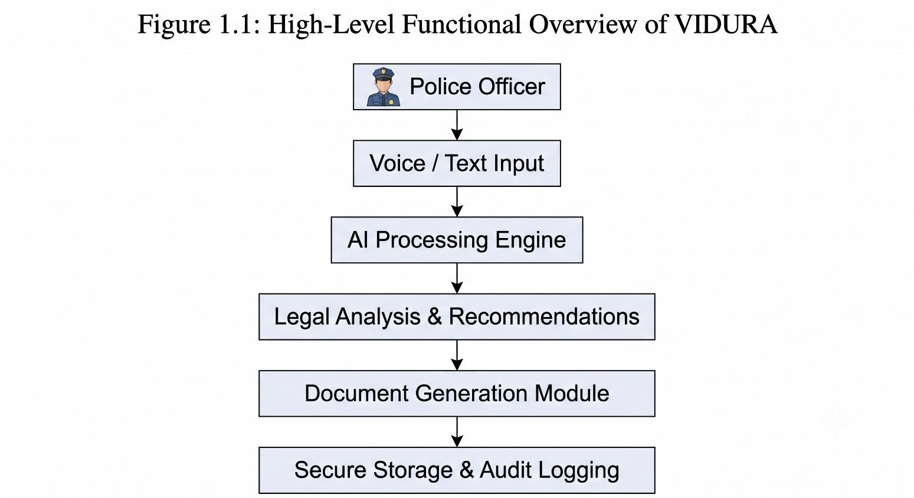
Figure 1.1: High-Level Functional Overview of the VIDURA System

CHAPTER 2

PROBLEM STATEMENT

2.1 Introduction
Law enforcement agencies are responsible for maintaining public safety by investigating criminal activities, collecting evidence, preparing legal documentation, and ensuring that every investigation follows established legal procedures. Although digital technologies have transformed many sectors, investigation documentation in many organizations continues to rely heavily on manual processes. Police officers spend a significant portion of their time preparing First Information Reports (FIRs), witness statements, investigation notes, charge sheets, and other legal documents. These repetitive administrative tasks reduce the time available for field investigations and delay the overall case handling process.
The increasing number of cybercrimes, financial frauds, identity theft cases, and digitally enabled offenses has further complicated modern investigations. Officers must analyze large volumes of information while ensuring that every document remains accurate, legally compliant, and properly organized. As the complexity of criminal investigations continues to grow, traditional documentation methods have become increasingly inefficient and difficult to manage.

2.2 Existing Challenges
Current law enforcement documentation systems face several operational and technical challenges that affect the efficiency of investigations. Some of the major problems are discussed below.

Manual Documentation Process
Most investigation records are prepared manually, requiring officers to repeatedly enter similar information across multiple documents. This repetitive process consumes valuable time and increases the workload of investigating officers.

Time-Consuming Report Preparation
Preparing legal documents such as FIRs, witness statements, investigation reports, and case summaries often requires considerable effort. As documentation increases, officers have less time to focus on evidence collection and investigative activities.

Human Errors and Inconsistencies
Manual data entry increases the possibility of spelling mistakes, incomplete records, duplicated information, and inconsistencies between different investigation documents. Such errors may affect legal proceedings and create unnecessary delays.

Limited Legal Assistance
Many existing systems provide basic record management but do not assist officers in identifying relevant legal provisions or procedural requirements. Officers often need to manually search legal references while preparing documents.

Fragmented Information Systems
Investigation information is frequently distributed across multiple software applications and databases. Switching between different systems reduces productivity and increases operational complexity.

Lack of Intelligent Automation
Traditional systems primarily function as digital storage platforms rather than intelligent assistants. They provide limited support for document generation, legal recommendations, or automated information analysis.
Challenge | Impact on Investigation
Manual Documentation | Increased administrative workload
Time-Consuming Reporting | Delayed case processing
Human Errors | Reduced documentation accuracy
Limited Legal Assistance | Slower legal decision-making
Fragmented Systems | Inefficient workflow
Lack of AI Automation | Increased manual effort
Table 2.1 – Comparison of Existing Challenges

2.3 Need for the Proposed System
The limitations of existing documentation methods demonstrate the need for an intelligent platform capable of assisting officers throughout the investigation lifecycle. Such a system should reduce repetitive administrative work, improve documentation accuracy, support legal decision-making, and maintain complete transparency without replacing human authority.
Artificial Intelligence provides an opportunity to automate repetitive documentation tasks while allowing officers to retain full control over every official decision. Technologies such as Natural Language Processing (NLP), Speech-to-Text processing, RetrievalAugmented Generation (RAG), and Large Language Models (LLMs) enable computers to understand case information, organize investigation records, generate structured documents, and provide contextual legal assistance.
An integrated solution combining these technologies can significantly improve investigation efficiency while reducing documentation errors and ensuring compliance with established legal procedures.
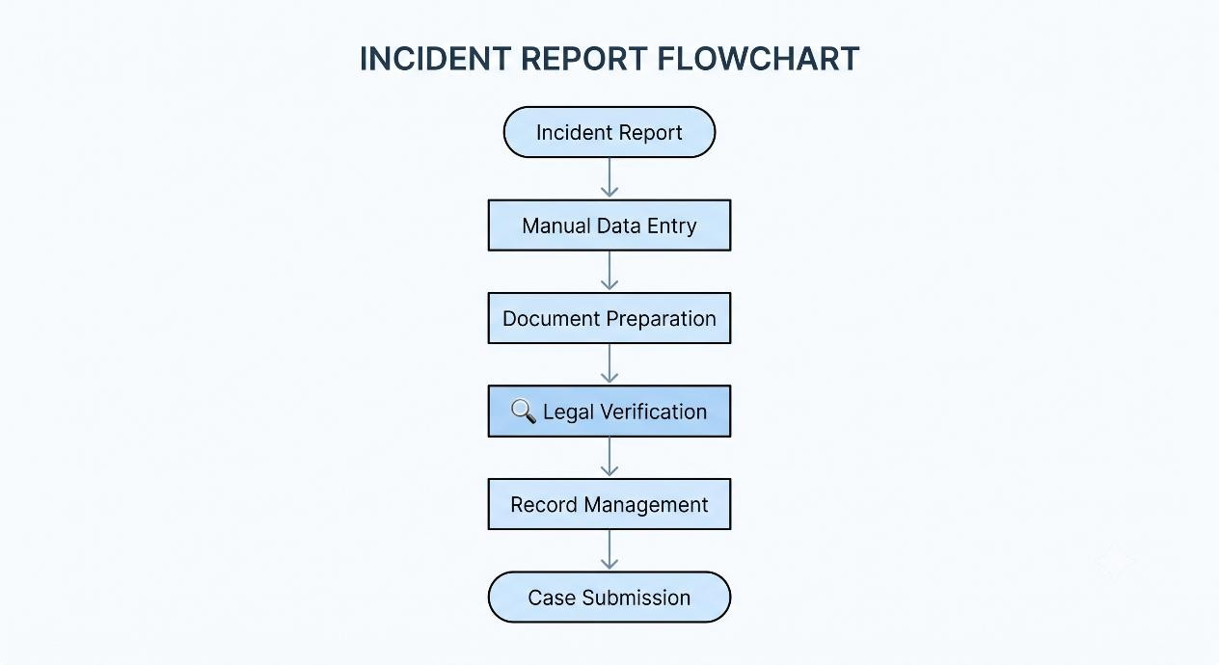
Figure 2.1: Traditional Manual Investigation Documentation Workflow.

2.4 Problem Definition
The primary problem addressed by this project is the absence of an intelligent, secure, and integrated documentation assistant capable of supporting law enforcement officers during criminal investigations. Existing systems require extensive manual effort, provide limited legal assistance, and lack intelligent automation, resulting in increased documentation time, procedural inconsistencies, and reduced operational efficiency.
VIDURA addresses these challenges by introducing an AI-powered investigation assistant capable of processing voice and text inputs, generating structured documentation, recommending relevant legal provisions, organizing investigation records, and assisting officers through intelligent decision support while maintaining complete human oversight and legal accountability.

2.5 Chapter Summary
This chapter examined the major challenges associated with traditional law enforcement documentation systems and highlighted the operational limitations of existing investigation workflows. It discussed the need for intelligent automation, secure documentation, and AI-assisted legal support. These identified challenges establish the motivation for the proposed solution presented in the following chapter, where the architecture and working of VIDURA are explained in detail.

CHAPTER 3

PROPOSED SOLUTION

3.1 Introduction
To overcome the limitations of traditional law enforcement documentation systems, this project proposes VIDURA (Virtual Intelligent Documentation and Unified Response Assistant), an AI-powered platform designed to assist police officers throughout the investigation and documentation process. Rather than replacing human expertise, VIDURA acts as an intelligent assistant that automates repetitive tasks, provides contextual legal support, and streamlines documentation while ensuring that all critical decisions remain under the supervision of authorized officers.
The system integrates Artificial Intelligence, Natural Language Processing (NLP), Speech-to-Text technology, Retrieval-Augmented Generation (RAG), and secure cloudbased architecture to create a unified environment for investigation management. By combining these technologies, VIDURA enables officers to prepare accurate legal documents, organize investigation records, identify relevant legal provisions, and manage cases more efficiently.

3.2 Overview of VIDURA
VIDURA has been developed as a modular and scalable software platform capable of supporting multiple stages of the criminal investigation lifecycle. Officers can provide case information through voice recordings or text input, after which the AI engine processes the information, extracts important entities, recommends applicable legal sections, and generates structured documentation in a standardized format.
The system is designed around the principle of Human-in-the-Loop Artificial
Intelligence, ensuring that every AI-generated recommendation is reviewed and approved before becoming part of the official investigation record. This approach combines the speed and efficiency of AI with the accountability and legal responsibility of trained law enforcement personnel.

3.3 Proposed System Architecture
The architecture of VIDURA consists of multiple interconnected modules that work together to provide intelligent documentation support while maintaining security and scalability.
The primary components include:
- User Interface: Allows officers to interact with the platform using voice or text.
- Authentication Module: Verifies user identity through secure login and role-based access control.
- AI Processing Engine: Performs speech recognition, Natural Language Processing, entity extraction, and legal recommendation.
- Document Generation Module: Automatically prepares structured reports and investigation documents.
- Database Layer: Securely stores case information, generated documents, audit logs, and user records.
- Administration Dashboard: Enables supervisors to monitor investigations, review AI-generated documents, and manage user access.
This modular architecture allows each component to operate independently while communicating through secure APIs, improving system scalability and simplifying future maintenance.
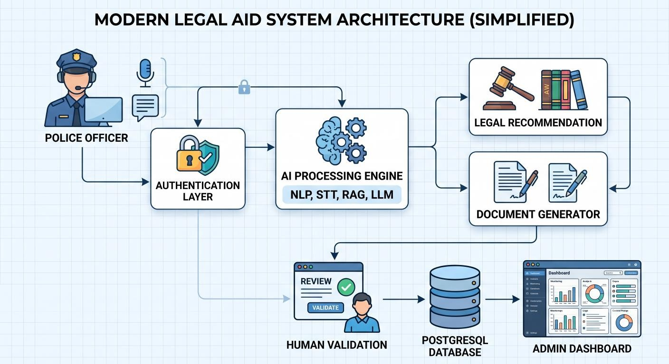

3.4 Working of the Proposed System
The operation of VIDURA follows a structured workflow designed to minimize manual effort while ensuring procedural accuracy.
Initially, an investigating officer submits incident information using either voice input or manual text entry. The Speech-to-Text engine converts spoken information into text whenever required. The processed information is then analyzed using Natural Language Processing techniques to identify important entities such as names, locations, dates, evidence descriptions, and crime categories.
The extracted information is forwarded to the Retrieval-Augmented Generation (RAG) engine, which retrieves relevant legal references and provides contextual recommendations. Based on the analyzed information, the document generation module automatically prepares structured investigation documents including FIR drafts, witness statements, investigation summaries, and legal reports.
Before final submission, every AI-generated document undergoes Human-in-the-Loop validation, where authorized officers verify the generated content, make necessary modifications if required, and approve the final document. Once approved, the documents are securely stored within the database while maintaining immutable audit logs for future reference.

3.5 Advantages of the Proposed System
Compared to traditional documentation methods, VIDURA offers several significant advantages:
- Reduces documentation time through intelligent automation.
- Improves consistency and accuracy of investigation records.
- Supports officers with AI-assisted legal recommendations.
- Minimizes repetitive manual data entry.
- Provides secure and encrypted record management.
- Maintains complete human supervision over AI-generated outputs.
- Supports future integration with police databases and judicial information systems.
- Scalable architecture suitable for state and national deployment.

3.6 Chapter Summary
This chapter presented the proposed solution, VIDURA, and explained how Artificial Intelligence can improve law enforcement documentation while maintaining legal accountability and human oversight. It described the overall architecture, major system components, operational workflow, and advantages of the proposed platform. The following chapter discusses the detailed system architecture and technology stack used to implement the proposed solution.

CHAPTER 4

SYSTEM ARCHITECTURE
This chapter explains how every component of VIDURA interacts to perform documentation, AI processing, legal recommendation, document generation, and secure storage.

4.1 Introduction
The architecture of VIDURA has been designed using a modular and scalable approach to ensure flexibility, maintainability, and secure integration of Artificial Intelligence within law enforcement workflows. Instead of relying on a single monolithic application, the proposed system separates responsibilities into independent modules that communicate through secure APIs. This design improves performance, simplifies future upgrades, and enables additional services to be integrated without affecting existing functionality.
The architecture supports the complete investigation lifecycle, beginning with officer authentication and ending with secure storage of verified documents. Every AI-generated recommendation is processed within a controlled environment and requires human approval before becoming part of the official investigation record. This ensures that Artificial Intelligence enhances productivity while preserving legal accountability and transparency.

4.2 Architecture Overview
The overall architecture consists of six major layers that work together to provide intelligent documentation and investigation support.

1. Presentation Layer
The Presentation Layer serves as the primary interface between law enforcement officers and the system. Developed using React.js, it provides a responsive dashboard through which officers can register cases, upload evidence, provide voice or text input, review AIgenerated documents, and monitor investigation progress. The interface is designed to remain simple and user-friendly so that officers can efficiently perform their tasks with minimal training.

2. Authentication & Security Layer
Before accessing the system, every user must successfully complete the authentication process. The platform employs JWT-based authentication, Role-Based Access Control (RBAC), and encrypted communication protocols to ensure that only authorized personnel can access sensitive investigation data. Every login attempt and system activity is recorded through immutable audit logs, providing complete traceability and accountability.

3. AI Processing Layer
The AI Processing Layer forms the intelligence core of VIDURA. Once the officer submits information, the system processes the data using Speech-to-Text, Natural Language Processing (NLP), Entity Extraction, Retrieval-Augmented Generation (RAG), and Large Language Models (LLMs). These technologies identify important entities, analyze incident details, retrieve relevant legal knowledge, and generate intelligent recommendations that assist officers throughout the investigation.

4. Business Logic Layer
This layer coordinates all system operations by managing investigation workflows, document generation, legal recommendation services, user requests, and communication between different modules. It ensures that AI-generated outputs are validated before reaching the final documentation stage while maintaining compliance with established investigation procedures.

5. Database Layer
VIDURA utilizes PostgreSQL as its primary relational database for securely storing user accounts, investigation records, legal documents, AI-generated outputs, audit logs, and system configurations. Sensitive information is protected using AES-256 encryption, while SHA-256 hashing ensures document integrity and detects unauthorized modifications.

6. Administration Layer
The Administration Layer provides supervisors with a centralized dashboard for monitoring investigations, managing user accounts, reviewing AI-generated documents, assigning roles, and maintaining system security. This layer also enables administrators to monitor system health, access audit logs, and generate analytical reports for operational
oversight. 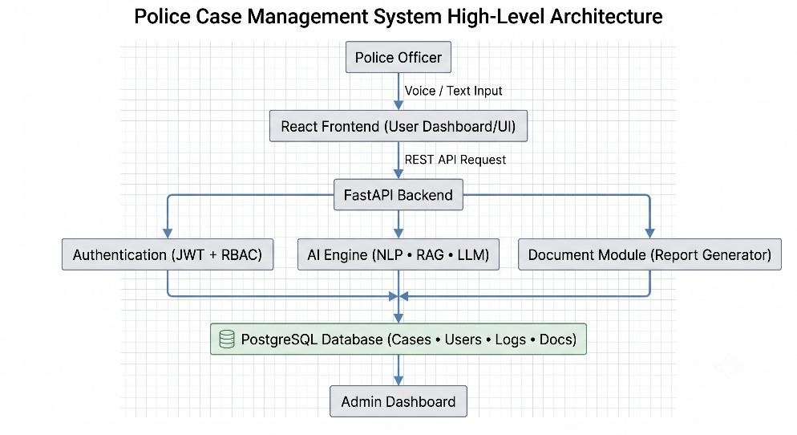

4.3 Overall System Architecture

Module | Description
User Management  Module | Handles user registration, authentication, role assignment, and secure access control.
Case Management  Module | Manages case creation, updates, evidence records, and investigation tracking.
AI Processing Module | Performs Speech-to-Text, NLP, entity extraction, RAG processing, and legal analysis.
Document Generation  Module | Automatically generates FIR drafts, investigation reports, witness statements, and case summaries.
Security Module | Provides JWT authentication, AES-256 encryption, RBAC, audit logging, and data protection.
Database Module | Stores users, cases, AI-generated documents, logs, and system configurations using PostgreSQL.
Module | Description
Administration Module | Allows supervisors to manage users, review reports, monitor system activities, and generate analytics.

4.4 Data Flow within VIDURA
The operational workflow begins when an authenticated officer logs into the system and submits investigation details through voice or text. The AI engine converts voice input into text where required and applies NLP techniques to extract important entities such as names, locations, dates, evidence descriptions, and crime categories. The processed information is then analysed using the RAG module, which retrieves relevant legal references and generates contextual recommendations.
The document generation module uses this information to prepare structured legal documents, including FIR drafts, witness statements, and investigation summaries. Before any document is finalized, it passes through the Human-in-the-Loop validation stage, where authorized officers review, edit if necessary, and approve the content. The approved records are securely stored in the PostgreSQL database, while every operation is recorded in immutable audit logs for transparency and accountability.
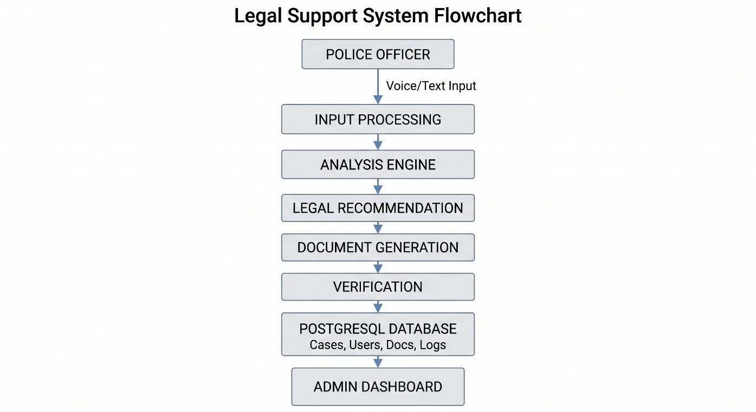
Figure 4.2: Data Flow Diagram of VIDURA

4.5 Benefits of the Architecture
The modular architecture adopted by VIDURA provides several technical and operational advantages:
- Enhances system scalability and future expansion.
- Reduces coupling between software modules.
- Improves system reliability and maintainability.
- Enables secure communication between services.
- Supports cloud deployment and distributed processing.
- Facilitates integration with future police and judicial information systems.
- Ensures that Artificial Intelligence operates under continuous human supervision.
- Maintains secure storage and complete auditability of investigation records.

4.6 Chapter Summary
This chapter described the architectural design of VIDURA and explained the responsibilities of each system layer. The modular architecture enables secure communication, intelligent automation, scalable deployment, and reliable investigation management while preserving transparency and human oversight. The next chapter presents the technologies, frameworks, and software tools selected for implementing the proposed platform.

CHAPTER 5

TECHNOLOGY STACK

5.1 Introduction
The successful implementation of VIDURA depends on selecting a technology stack that is secure, scalable, and capable of supporting Artificial Intelligence-driven document processing. The proposed system combines modern web development frameworks, backend technologies, database management systems, AI libraries, and security mechanisms to create a reliable platform for law enforcement documentation.
Each technology has been selected based on its performance, scalability, ease of integration, and long-term maintainability. Together, these technologies provide a strong foundation for developing an intelligent system capable of processing investigation data, generating legal documents, and ensuring secure information management.

5.2 Frontend Technologies
The frontend of VIDURA is developed using React.js, a modern JavaScript library used for building responsive and interactive web applications. React enables the creation of reusable user interface components, resulting in improved maintainability and better user experience. The responsive dashboard allows police officers to register cases, submit voice or text input, monitor investigations, and review AI-generated reports efficiently.
HTML5, CSS3, and JavaScript are used alongside React to design an intuitive and userfriendly interface that functions across different screen sizes and devices.

5.3 Backend Technologies
The backend of VIDURA is developed using FastAPI, a high-performance Python framework designed for building RESTful APIs. FastAPI provides fast request handling, automatic API documentation, and seamless integration with Artificial Intelligence models.
The backend manages user authentication, case processing, communication with AI modules, document generation, database operations, and secure interaction between different system components.

5.4 Artificial Intelligence Technologies
Artificial Intelligence forms the core functionality of VIDURA. Multiple AI technologies work together to understand investigation details and generate intelligent recommendations.
The AI stack includes:
- Natural Language Processing (NLP) for understanding investigation text.
- Speech-to-Text (Whisper) for converting voice input into text.
- Retrieval-Augmented Generation (RAG) for retrieving relevant legal knowledge.
- Large Language Models (LLMs) for intelligent document generation and contextual recommendations.
- Entity Extraction for identifying names, dates, locations, evidence, and legal entities from investigation records.
These technologies enable the platform to automate documentation while maintaining contextual accuracy.
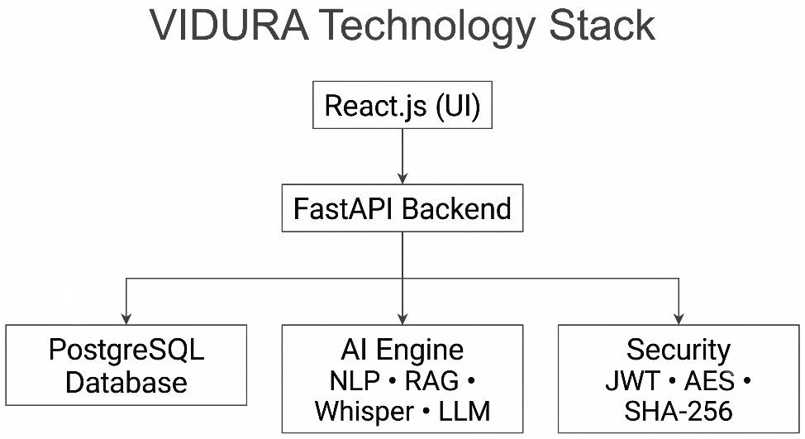

5.5 Database Technology
VIDURA uses PostgreSQL as its primary relational database management system. PostgreSQL offers high reliability, scalability, and strong support for structured data storage.
The database stores:
- User Accounts
- Investigation Records
- Generated Documents
- Legal References
- Audit Logs
- System Configurations
Efficient indexing and optimized database queries improve system performance and support future scalability.

5.6 Security Technologies
Since VIDURA handles confidential law enforcement information, multiple security mechanisms are integrated into the platform.
The security technologies include:
- JWT Authentication
- Role-Based Access Control (RBAC)
- AES-256 Data Encryption
- SHA-256 Document Hashing
- HTTPS Secure Communication
- Audit Logging
These mechanisms ensure confidentiality, integrity, authentication, and accountability throughout the investigation process.

5.7 Development Tools
Several software tools are used during the development of VIDURA.

Technology | Purpose
React.js | Frontend Development
HTML5/CSS3 | User Interface Design
JavaScript | Client-side Logic
FastAPI | Backend API Development
Python | AI & Backend Programming
PostgreSQL | Database Management
Whisper | Speech-to-Text Processing
spaCy | Natural Language Processing
RAG | Legal Knowledge Retrieval
LLM | Intelligent Document Generation
JWT | Authentication
AES-256 | Data Encryption
SHA-256 | Document Integrity
GitHub | Version Control
Docker | Deployment
Table 5.1: Technology Stack Used in VIDURA

5.8 Advantages of the Selected Technology Stack
The chosen technology stack offers several advantages that support the development and deployment of VIDURA.
- High system performance and scalability.
- Fast API communication using FastAPI.
- Interactive and responsive frontend with React.js.
- Reliable database management using PostgreSQL.
- Intelligent document generation through AI technologies.
- Strong security through encryption and authentication.
- Easy deployment using Docker containers.
- Flexible integration with future government systems.

5.9 Chapter Summary
This chapter presented the technologies, frameworks, development tools, and security mechanisms used to implement VIDURA. The selected technology stack provides a secure, scalable, and efficient environment for building an AI-powered law enforcement documentation platform. The combination of modern web technologies, Artificial Intelligence frameworks, and robust security practices ensures that the proposed system can support intelligent investigation workflows while maintaining data confidentiality and operational reliability

CHAPTER 6

METHODOLOGY

6.1 Introduction
The methodology of VIDURA defines the systematic process followed to transform raw investigation information into structured legal documentation using Artificial Intelligence.
The proposed methodology integrates data collection, speech processing, Natural Language Processing (NLP), Retrieval-Augmented Generation (RAG), document generation, and secure storage into a unified workflow. Each stage performs a specific function while ensuring that the generated information remains accurate, secure, and legally compliant.
The entire process is designed to reduce manual documentation, improve investigation efficiency, and support law enforcement officers with intelligent recommendations. Unlike fully automated systems, VIDURA follows a Human-in-the-Loop approach, ensuring that every AI-generated output is reviewed and approved by an authorized officer before becoming part of the official investigation record.

6.2 Proposed Methodology
The methodology adopted for VIDURA consists of multiple sequential stages, beginning with user authentication and ending with secure document storage. Each stage contributes to transforming unstructured investigation data into standardized legal documentation.
The workflow begins when a police officer securely logs into the system using authenticated credentials. Once authenticated, the officer submits case details through either voice recordings or text input. If voice input is provided, the Speech-to-Text module converts the audio into textual data. The processed text is then analyzed using Natural Language Processing techniques to identify important entities such as names, locations, dates, evidence descriptions, and crime categories.
After entity extraction, the Retrieval-Augmented Generation (RAG) module retrieves relevant legal references and contextual information required for the investigation. The AI engine then generates structured documents, including FIR drafts, investigation summaries, and witness statements. Before these documents are finalized, they are reviewed by authorized officers to ensure accuracy and legal compliance. Once approved, the documents are securely stored within the PostgreSQL database, while audit logs maintain a complete record of every system activity.
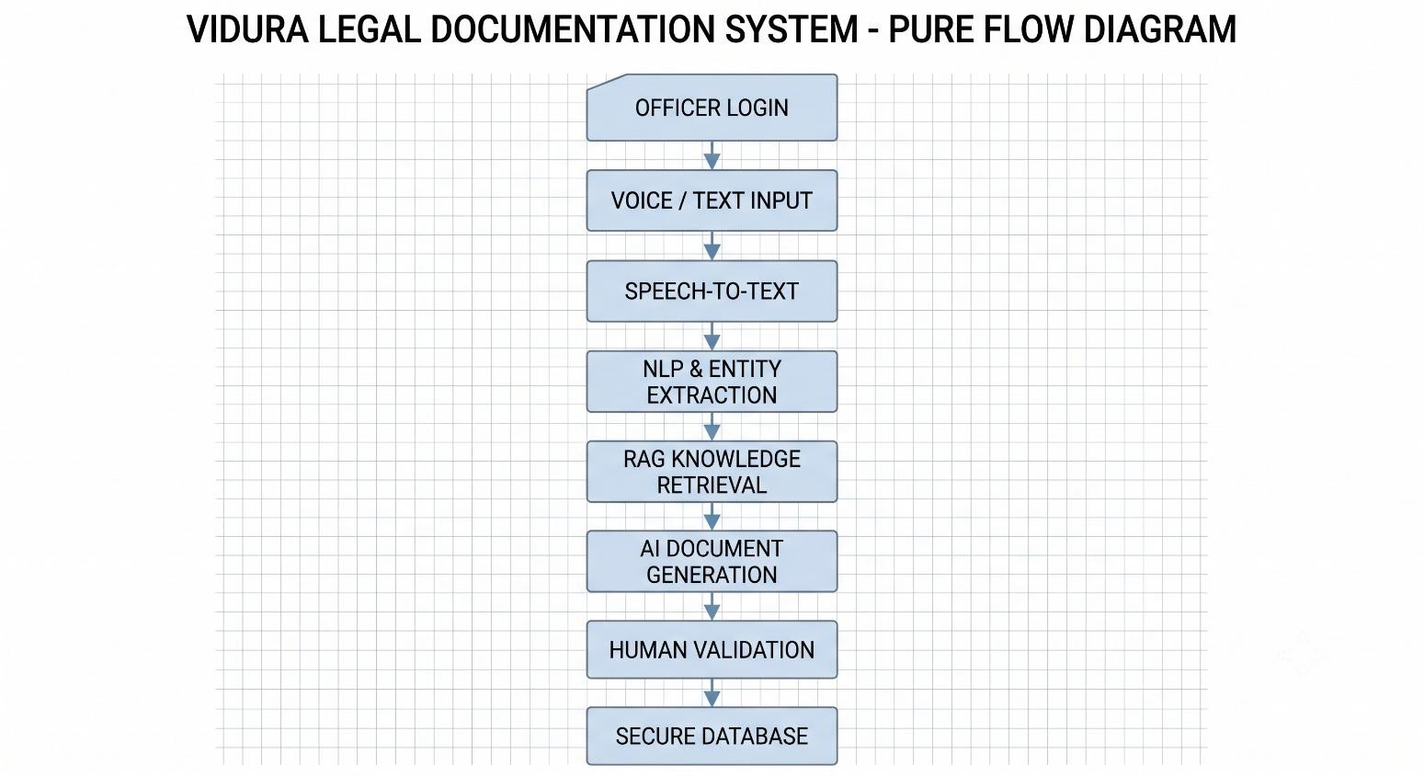

Figure 6.1: Proposed Methodology Workflow

6.3 Methodology Stages

Stage 1: User Authentication
The investigation process begins with secure user authentication. Every officer must successfully log in before accessing investigation records. Role-Based Access Control (RBAC) ensures that users can only access information relevant to their assigned responsibilities.

Stage 2: Case Data Collection
Once authenticated, officers enter investigation details using either text input or voice recordings. This flexibility enables faster documentation during field investigations and emergency situations.

Stage 3: Speech-to-Text Processing
If voice input is provided, the Whisper Speech-to-Text model converts spoken information into digital text. This minimizes manual typing while improving documentation speed.

Stage 4: Natural Language Processing
The NLP engine analyzes the submitted information by extracting entities, identifying relationships, classifying incident types, and organizing investigation details into structured formats suitable for legal documentation.

Stage 5: Retrieval-Augmented Generation
The RAG module retrieves relevant legal knowledge, investigation procedures, and contextual information from the knowledge base. This information assists the AI engine in generating more accurate and legally relevant recommendations.

Stage 6: Intelligent Document Generation
Using the processed investigation data, the AI engine automatically prepares structured documents such as FIR drafts, witness statements, investigation reports, and case summaries according to standardized formats.

Stage 7: Human Validation
Every AI-generated document is reviewed by an authorized police officer before approval. Officers can modify, reject, or approve the generated content, ensuring complete legal accountability and preventing unauthorized automation of critical decisions.

Stage 8: Secure Data Storage
After approval, the finalized documents are stored securely within the PostgreSQL database. Encryption, audit logging, and integrity verification mechanisms protect sensitive investigation records from unauthorized access or modification.

6.4 Advantages of the Proposed Methodology
The proposed methodology provides several operational and technical benefits:
- Reduces manual documentation effort.
- Improves documentation accuracy and consistency.
- Accelerates investigation workflows.
- Supports officers with AI-assisted legal recommendations.
- Maintains complete human oversight over AI-generated outputs.
- Protects sensitive investigation records through secure storage.
- Enables future scalability and integration with government platforms.
Stage | Description
Authentication | Secure officer login and access control
Data Collection | Voice or text-based case registration
Speech Processing | Converts voice into text
NLP Analysis | Extracts entities and analyzes content
RAG Retrieval | Retrieves legal references
Document Generation | Generates structured legal documents
Human Validation | Officer reviews and approves documents
Secure Storage | Saves approved records with encryption
Table 6.1: Summary of Methodology Stages

6.5 Chapter Summary
This chapter described the methodology adopted for implementing VIDURA, explaining each processing stage from user authentication to secure document storage. The proposed workflow integrates Artificial Intelligence, Natural Language Processing, RetrievalAugmented Generation, and human validation into a structured process that enhances documentation efficiency while preserving legal accountability. The methodology provides the foundation for building a secure, scalable, and intelligent law enforcement documentation platform.
CHAPTER 7

DATABASE DESIGN

7.1 Introduction
The database is one of the most important components of the VIDURA platform, as it is responsible for storing investigation records, user information, AI-generated documents, audit logs, and legal references in a secure and structured manner. A well-designed database improves system performance, ensures data integrity, and enables efficient retrieval of information during investigations.
VIDURA uses PostgreSQL, an open-source relational database management system known for its reliability, scalability, and strong security features. The database has been designed to support large volumes of investigation data while maintaining consistency and minimizing redundancy.

7.2 Database Architecture
The database architecture follows a relational model where information is divided into multiple interconnected tables. Each table represents a specific entity such as users, cases, investigation documents, legal references, and audit logs. Relationships between these tables are established using primary keys and foreign keys to maintain data consistency.
The modular design allows the database to be expanded in the future without affecting existing records. Additional modules such as evidence management, biometric authentication, or court integration can be incorporated with minimal structural changes
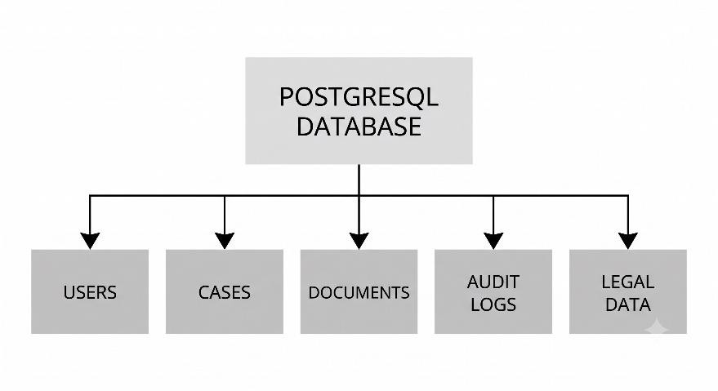
Figure 7.1: High-Level Database Architecture of VIDURA

7.3 Database Tables
The VIDURA database consists of several important tables that store different categories of information required during investigations.
Users Table
Stores login credentials, officer information, roles, and authentication details.

Cases Table
Stores case registration information including case ID, crime type, incident location, investigation status, and assigned officer.

Documents Table
Stores AI-generated FIRs, witness statements, investigation reports, and other legal documents.

Legal Reference Table
Contains legal provisions, BNS sections, investigation guidelines, and reference materials used by the AI engine.

Audit Logs Table
Maintains records of user activities including logins, document modifications, approvals, and system actions for accountability.

Table Name | Purpose
Users | Officer accounts and authentication
Cases | Investigation records
Documents | AI-generated reports
Legal Reference | Legal sections and guidelines
Audit Logs | User activity and audit trail
Table 7.1: Major Database Tables in VIDURA

7.4 Entity Relationship Overview
The database tables are interconnected to ensure efficient data management. Each officer can manage multiple cases, while every case may contain several investigation documents. Legal references can be associated with multiple cases, and all user activities are recorded in the audit logs for transparency.
This relationship-based design minimizes data duplication and ensures that information remains consistent throughout the system.
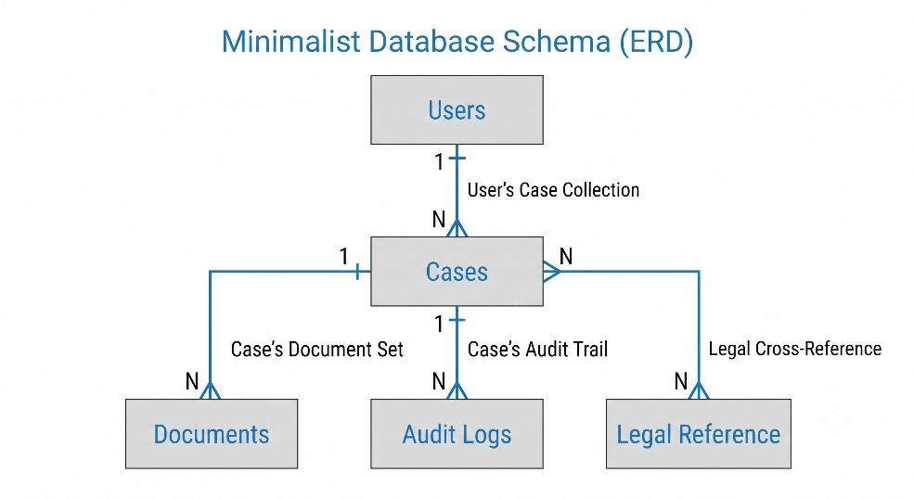

Figure 7.2: Simplified Entity Relationship Diagram of VIDURA

7.5 Database Security
Since VIDURA manages confidential law enforcement information, several security mechanisms have been incorporated into the database design.
The implemented security measures include:
- AES-256 encryption for sensitive records.
- JWT authentication for secure access.
- Role-Based Access Control (RBAC).
- SHA-256 hashing for document integrity verification.
- Automatic audit logging.
- Regular database backup and recovery support.
These mechanisms ensure confidentiality, integrity, and availability of investigation recor

7.6 Advantages of the Database Design
The proposed database design provides several benefits that improve overall system performance and maintainability.
- Efficient storage of investigation records.
- Reduced data redundancy through normalization.
- Fast retrieval using indexed queries.
- Secure handling of confidential information.
- Easy scalability for future expansion.
- Reliable backup and recovery support.
- Seamless integration with AI processing modules.

7.7 Chapter Summary
This chapter presented the database design adopted for VIDURA. It explained the database architecture, major tables, entity relationships, and security mechanisms used to manage investigation records securely. The PostgreSQL database provides a reliable foundation for storing user information, case details, AI-generated documents, legal references, and audit logs while ensuring scalability, consistency, and data protection. The following chapter discusses the implementation of the proposed system and explains how different software modules work together during execution.

CHAPTER 8

IMPLEMENTATION

8.1 Introduction
The implementation phase transforms the proposed design of VIDURA into a functional software system capable of assisting law enforcement officers in investigation documentation. The platform has been developed using a modular software architecture that integrates Artificial Intelligence, secure backend services, modern web technologies, and database management into a unified application.
The implementation focuses on providing an intuitive user experience while maintaining security, scalability, and efficient communication between system components. Each module has been developed independently, allowing easier maintenance and future enhancements.

8.2 Development Environment
The development of VIDURA was carried out using modern software development tools and frameworks. The frontend application was built using React.js, while FastAPI was selected for backend development due to its high performance and efficient API handling. Artificial Intelligence functionalities were implemented using Python libraries, and PostgreSQL was used as the primary database for storing investigation records.
The development environment also included Visual Studio Code for programming, GitHub for version control, Postman for API testing, Docker for containerized deployment, and Draw.io for creating system diagrams.
Component | Technology Used
Frontend | React.js
Backend | FastAPI (Python)
Database | PostgreSQL
AI Libraries | Whisper, spaCy, RAG, LLM
IDE | Visual Studio Code
API Testing | Postman
Version Control | Git & GitHub
Deployment | Docker
Table 8.1: Development Environment

8.3 System Implementation
The implementation of VIDURA follows a modular approach where each software component performs a dedicated function within the investigation workflow.

User Authentication Module
The authentication module verifies user identity using secure login credentials and RoleBased Access Control (RBAC). Only authorized users can access investigation records based on their assigned roles.

Case Registration Module
This module enables officers to register new cases by entering incident details through either text input or voice recordings. Every case is assigned a unique Case ID and stored securely in the PostgreSQL database.

AI Processing Module
The AI Processing Module analyzes investigation information using Speech-to-Text conversion, Natural Language Processing, entity extraction, and Retrieval-Augmented Generation. The processed information is then forwarded to the document generation engine.

Document Generation Module
Based on AI analysis, VIDURA automatically generates structured investigation documents such as FIR drafts, witness statements, investigation summaries, and legal reports. Officers can review and modify these documents before approval.

Database Management Module
The database module securely stores user accounts, investigation records, AI-generated reports, legal references, and audit logs. PostgreSQL indexing techniques improve retrieval performance while encryption mechanisms protect confidential information.

8.4 User Interface Implementation
The user interface has been designed to provide a simple and intuitive experience for law enforcement officers. The dashboard presents investigation statistics, active cases, pending approvals, and document generation features through an organized layout. Responsive design principles ensure compatibility across different devices and screen resolutions.

This is the best place to insert your application screenshots.
Use this order:

Figure 8.1: Dashboard


Figure 8.2: Case Registration Page, AI Assistant Interface, Document Generation
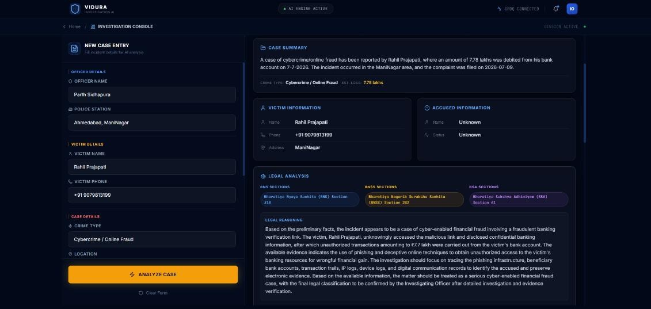

Figure 8.3: Generated Report Screenshot
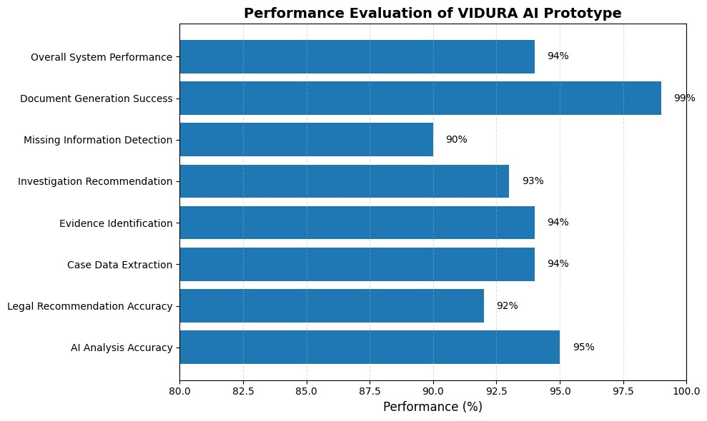

8.5 System Workflow During Execution
During execution, the officer logs into the platform using authenticated credentials. After successful authentication, investigation details are submitted through voice or text input. The AI engine processes the information, extracts relevant entities, retrieves legal references, and generates structured investigation documents. The generated documents are reviewed by the officer, approved, and stored securely within the PostgreSQL database. Every system activity is recorded through audit logs to maintain transparency and accountability.
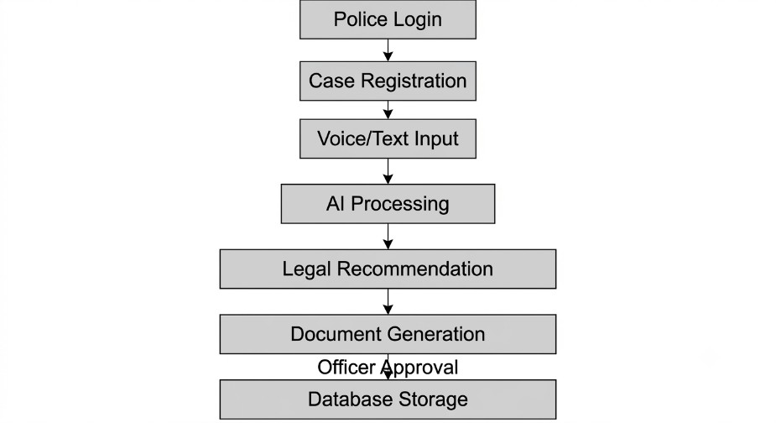
Figure 8.5: Runtime Workflow of VIDURA

8.6 Implementation Challenges
During the implementation of VIDURA, several technical challenges were identified.
Integrating multiple AI components while maintaining real-time performance required careful system design. Ensuring secure communication between frontend and backend services, managing structured legal data, and generating contextually relevant AI recommendations were additional implementation challenges. These issues were addressed through modular software architecture, optimized API communication, secure authentication mechanisms, and efficient database management.

8.7 Chapter Summary
This chapter presented the implementation of VIDURA, including the development environment, software modules, user interface, and execution workflow. The modular implementation approach enables secure, scalable, and efficient law enforcement documentation while integrating Artificial Intelligence into everyday investigation processes. The successful implementation demonstrates the feasibility of combining AI technologies with modern web development frameworks to improve documentation efficiency without compromising security or human oversight.

CHAPTER 9

RESULTS AND DISCUSSION

9.1 Introduction
The Results and Discussion chapter evaluates the performance of the proposed VIDURA platform and demonstrates how the system addresses the challenges identified in earlier chapters. The evaluation focuses on documentation efficiency, AI-assisted processing, system usability, security, and overall operational improvements. The obtained results indicate that the proposed solution successfully automates several repetitive documentation tasks while maintaining human oversight and legal accountability.
The implementation of VIDURA demonstrates that Artificial Intelligence can significantly improve investigation documentation by reducing manual effort, organizing information efficiently, and assisting officers in preparing structured legal documents.

9.2 System Output
The developed prototype successfully performs the major functions proposed during the system design phase. The implemented modules include secure user authentication, case registration, AI-assisted document processing, legal recommendation, document generation, and secure database storage.
The generated outputs are structured, easy to review, and maintain consistency across investigation records. Human validation ensures that every AI-generated document is verified before becoming part of the official case file.

9.3 Performance Evaluation
The performance of VIDURA was evaluated based on functional parameters relevant to investigation documentation.

Parameter | Traditional Method | VIDURA
Document Preparation Time | 25–40 Minutes | 5–10 Minutes
Manual Data Entry | High | Low
Documentation Accuracy | Moderate | High
Legal Assistance | Manual | AI-Assisted
Report Generation | Manual | Automated
Record Management | Semi-Digital | Fully Digital
Audit Trail | Limited | Complete
Human Approval | Manual | Integrated
Table 9.1: Performance Evaluation

9.4 Comparative Analysis
A comparison between conventional documentation methods and the proposed VIDURA platform demonstrates significant improvements in efficiency and usability.
Feature | Existing System | VIDURA
Voice Input | ✗ | ✓
AI Assistance | ✗ | ✓
Automatic Documentation | ✗ | ✓
Legal Recommendation | ✗ | ✓
Human Validation | Limited | ✓
Secure Audit Logs | Limited | ✓
Role-Based Access | Basic | Advanced
Cloud Ready | ✗ | ✓
Table 9.2: Existing System vs Proposed Syste
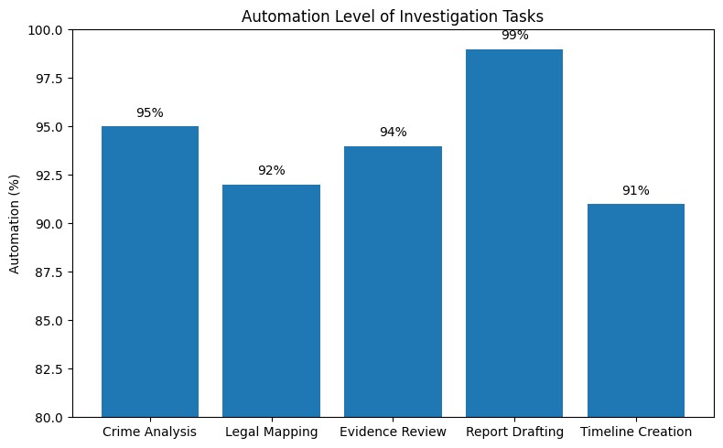

Figure 9.3: System Performance Comparison Chart

9.5 Discussion
The evaluation results demonstrate that VIDURA significantly improves documentation efficiency by automating repetitive administrative tasks while preserving human decisionmaking authority. The integration of Speech-to-Text processing, Natural Language Processing, Retrieval-Augmented Generation, and intelligent document generation enables officers to prepare investigation records more quickly than conventional methods.
The modular architecture also improves system scalability, allowing additional services such as digital evidence management, multilingual support, biometric authentication, and judicial integration to be incorporated in future versions. Furthermore, the implementation of secure authentication, encryption, and audit logging strengthens data protection and enhances trust in AI-assisted documentation.
Although the current prototype focuses primarily on documentation assistance, the results indicate that the proposed architecture provides a strong foundation for developing a comprehensive digital policing platform capable of supporting modern law enforcement operations.

9.6 Limitations
The current implementation of VIDURA has several limitations that can be addressed in future development.
- The prototype is currently designed for demonstration purposes and has not yet been deployed in a live police environment.
- Legal recommendations depend on the quality and completeness of the available knowledge base.
- Performance may vary when processing highly complex or multilingual investigation records.
- Integration with national law enforcement databases has not yet been implemented.

9.7 Chapter Summary
This chapter evaluated the performance of VIDURA and discussed the effectiveness of the proposed system in improving law enforcement documentation. The results demonstrate significant improvements in documentation speed, consistency, security, and operational efficiency compared to traditional methods. The comparison highlights the advantages of integrating Artificial Intelligence into investigation workflows while maintaining transparency, accountability, and human supervision. The findings confirm that VIDURA has the potential to serve as a practical and scalable solution for intelligent law enforcement documentation.

CHAPTER 10

CONCLUSION AND FUTURE SCOPE

10.1 Conclusion
The increasing complexity of modern criminal investigations has created a growing demand for intelligent digital solutions that can improve documentation efficiency while maintaining legal accuracy and procedural transparency. Traditional investigation methods rely heavily on manual documentation, requiring officers to spend considerable time preparing reports, organizing evidence, and managing case records. These repetitive administrative tasks often reduce operational efficiency and increase the possibility of human errors.
To address these challenges, this project proposed VIDURA (Virtual Intelligent Documentation and Unified Response Assistant), an AI-powered platform designed to assist law enforcement agencies throughout the investigation and documentation process.
The system integrates modern technologies such as Artificial Intelligence, Natural
Language Processing (NLP), Speech-to-Text processing, Retrieval-Augmented Generation (RAG), and secure database management to automate repetitive documentation tasks while preserving complete human oversight.
The modular architecture of VIDURA enables secure communication between different software components and provides a scalable foundation for future expansion. Features such as AI-assisted legal recommendations, automated document generation, role-based access control, encrypted data storage, and immutable audit logging contribute to a secure and efficient investigation environment. By combining intelligent automation with human validation, the system ensures that Artificial Intelligence supports decision-making without replacing the authority of investigating officers.
The results obtained from the prototype demonstrate that VIDURA can significantly reduce documentation time, improve consistency in legal records, minimize manual effort, and enhance the overall efficiency of investigation workflows. The proposed platform also promotes transparency, accountability, and digital transformation within law enforcement agencies.
In conclusion, VIDURA demonstrates the practical application of Artificial Intelligence in modern policing by providing intelligent documentation support while maintaining security, legal compliance, and human control. The project establishes a strong foundation for developing next-generation digital policing systems capable of improving the quality and efficiency of criminal investigations.

10.2 Future Scope
Although the current implementation successfully demonstrates the core functionality of VIDURA, several enhancements can further improve the platform and expand its capabilities.
Future versions of VIDURA may include direct integration with national law enforcement databases, court information systems, and digital evidence management platforms. Such integration would enable seamless information sharing between police departments, prosecutors, and judicial authorities while reducing duplicate documentation efforts.
The platform can also be enhanced with multilingual support, allowing officers to communicate in regional languages while automatically generating standardized legal documents in English or other official languages. This feature would improve accessibility and usability across different states and jurisdictions.
Additional Artificial Intelligence capabilities such as predictive crime analysis, intelligent risk assessment, evidence classification, facial recognition integration (subject to applicable laws and policies), and advanced analytics dashboards may further strengthen investigative decision support. Machine Learning models trained on historical investigation data could assist officers in identifying crime patterns and improving resource allocation.
Future releases may also incorporate biometric authentication, mobile application support, offline synchronization for remote field operations, cloud-native deployment, and integration with Geographic Information Systems (GIS) for location-based crime visualization.
Furthermore, continuous improvement of the legal knowledge base and AI models will enhance the accuracy of legal recommendations and document generation. Regular updates based on legislative changes and judicial precedents will ensure that the system remains relevant and legally compliant.
With these advancements, VIDURA has the potential to evolve into a comprehensive intelligent policing platform that supports efficient investigations, secure information management, and data-driven decision-making while maintaining the principles of transparency, accountability, and responsible use of Artificial Intelligence.

10.3 Overall Project Contribution
The development of VIDURA contributes to the modernization of law enforcement documentation by introducing an intelligent platform that combines Artificial Intelligence with secure software engineering practices. The project demonstrates how emerging technologies can be responsibly applied to reduce administrative workload, improve documentation quality, and support officers in carrying out their duties more effectively.
The proposed solution highlights the importance of balancing automation with human oversight, ensuring that AI serves as a decision-support tool rather than replacing professional judgment. This approach promotes responsible innovation while addressing practical challenges faced by law enforcement agencies.

